

**CONTAINERS AND DOCKERS**

**Submitted by:**

**NAME: Tanishqua Tellakula**

**SAP ID: 500084269**

**Roll number :R120220007**

**Batch: B1(Hons)**

***Lab Exercise 3: Working with Docker Volumes***

***Objective:***

* *Learn how to create and manage Docker volumes.*
* *Understand how Docker volumes can be used to persist data across container restarts.*
* *Practice mounting Docker volumes to containers.*

***Prerequisites:***

* *Docker installed on your system.*
* *Basic understanding of Docker commands and container concepts.*

***Step 1: Create a Docker Volume***

*Create a new Docker volume:*

|  |
| --- |
| ***docker volume create my_data_volume*** |

*This command creates a Docker volume named my_data_volume.*

*Verify that the volume was created:*

|  |
| --- |
| ***docker volume ls*** |

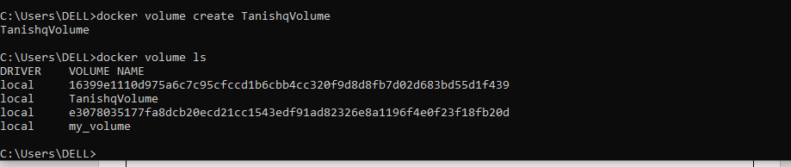

***Step 2: Run a Container with the Volume Mounted***

*Run an Nginx container with the volume mounted:*

|  |
| --- |
| ***docker run -d --name my_nginx -v my_data_volume:/usr/share/nginx/html -p 8008:80 nginx*** |

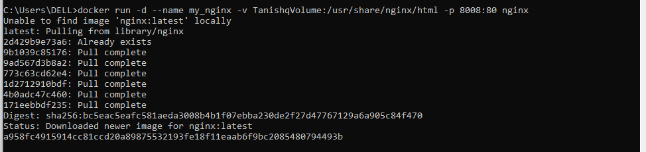

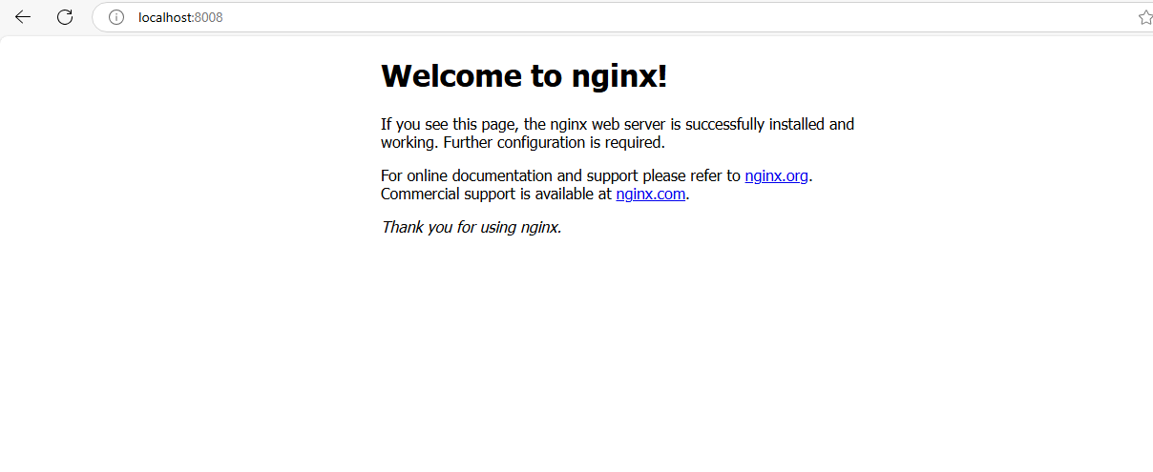

*This command starts an Nginx container named my_nginx and mounts the my_data_volume volume to the /usr/share/nginx/html directory inside the container.*

*Verify that the container is running:*

|  |
| --- |
| ***docker ps***  ***You should see my_nginx listed as one of the running containers.*** |

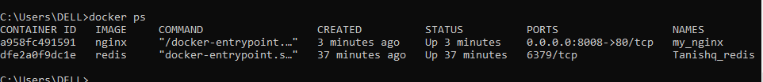

***Step 3: Interact with the Volume***

*Create a simple HTML file in the volume:*

***docker exec -it my_nginx bash***

***echo "<h1>Hello, Docker Volume</h1>" > /usr/share/nginx/html/index.html***

***exit***

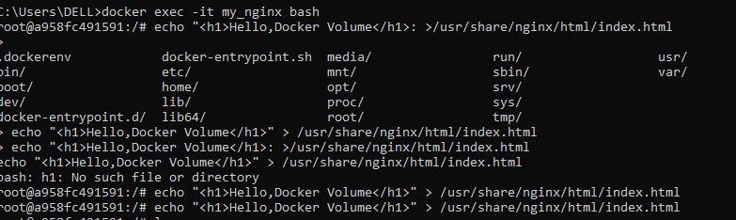

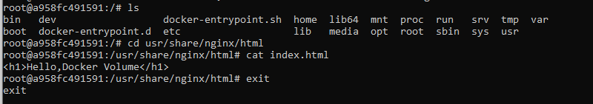

*This command creates an HTML file inside the /usr/share/nginx/html directory, which is backed by my_data_volume.*

*Access the Nginx server to see your file: Open a browser and navigate to http://localhost:8008. You should see the message "Hello, Docker Volume!" displayed on the page.*

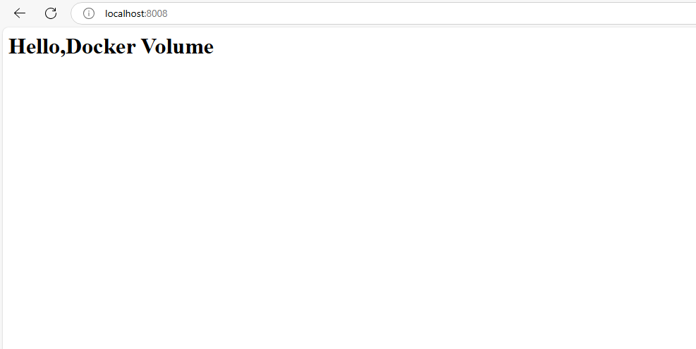

***Step 4: Test Data Persistence***

*Stop and remove the container:*

|  |
| --- |
| ***docker stop my_nginx***  ***docker rm my_nginx*** |

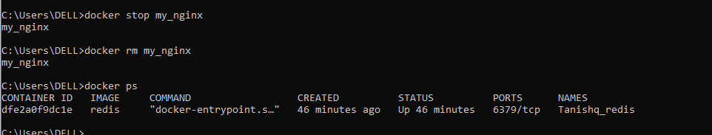

*Run a new Nginx container using the same volume:*

|  |
| --- |
| ***docker run -d -p 8011:80 -v my_data_volume:/usr/share/nginx/html nginx*** |

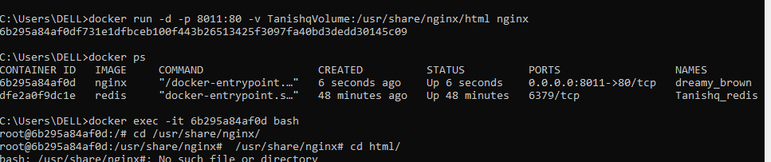

*Access the Nginx server again: Navigate to http://localhost in your browser. You should still see the "Hello, Docker Volume!" message, demonstrating that the data persisted across container instances.*

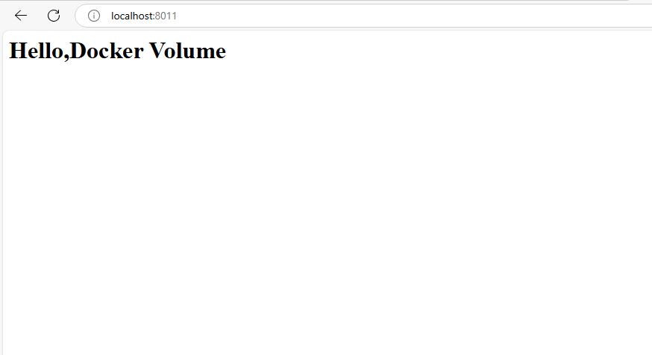

***Step 5: Clean Up***

*Stop and remove the container:*

|  |
| --- |
| ***docker stop new_nginx***  ***docker rm new_nginx*** |

*Remove the Docker volume:*

|  |
| --- |
| ***docker volume rm my_data_volume*** |

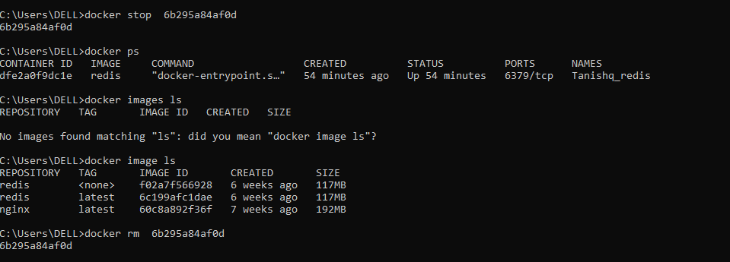

*Verify that the volume is removed:*

|  |
| --- |
| ***docker volume ls*** |

*Ensure that my_data_volume is no longer listed.*

